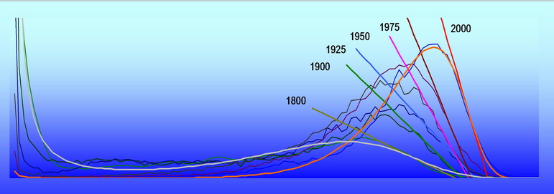 | Demographics 2012
http://www.demographicanalysis.net/quantmethworkshoptutor.html

QMDWT

Quantitative Methods in Demography Workshop and Tutorial

Chania, Crete, Greece, June 8, 2012

REGISTRATION FORM

PERSONAL INFORMATION
Title: □ Prof □ Dr □ Mr □ Mrs □ Ms
Family name: …………………………………………… First name(s): …………………………………………………….
Affiliation: …………………………………………………………………………………………………………………………..
………………………………………………………………………………………………………………………………………
Address: …………………………………………………………………………………………………………………………….
………………………………………………………………………………………………………………………………………
City: …………………………………… Area code: …………………… Country: ……………………………………....
Tel: ………………………………… Fax: …………………… e-mail: ……………………………………........

QMDWT registration* | Early Registration  Before March 30 | Late Registration  After March 30
□ Demographics 2012 Conference Participant | Free of Charge | 100 €
□ Only QMDWT Participant | 150 € | 200 €
□ Student registration | 100 € | 150 €
Total

*Please fill and return this registration form by email to: secretariat@demographicanalysis.net

All the QMDWT participants will receive a copy of the computer programs used and related documentation.

Date: ………………………………………… Name and/or Signature: ………………………………………….

